**Integrating the Healthcare Enterprise**



**IHE ITI**

**Technical Framework Supplement**

**Patient Resource Identity Management**

**(PRIM)**

HL7® FHIR® R4

Using Resources at FMM Level 3-N

**Revision 0.1 – Draft in Preparation for Public Comment**

Date: <Month xx, 20xx>

Author: ITI Technical Committee

Email: <domain_name@ihe.net>

**Please verify you have the most recent version of this document.** See [here](http://ihe.net/Technical_Frameworks/) for Trial Implementation and Final Text versions and [here](http://ihe.net/Public_Comment/) for Public Comment versions.

**Foreword**

This is a supplement to the IHE ITI Technical Framework <VX.X>. Each supplement undergoes a process of public comment and trial implementation before being incorporated into the volumes of the Technical Frameworks.

This supplement is published on <Month XX, 201x> for Public Comment. Comments are invited and can be submitted at <http://www.ihe.net/Public_Comment/#domainname>. In order to be considered in development of the Trial Implementation version of the supplement, comments must be received by <Month XX,

This supplement describes changes to the existing technical framework documents.

“Boxed” instructions like the sample below indicate to the Volume Editor how to integrate the relevant section(s) into the relevant Technical Framework volume.

*Amend section X.X by the following:*

Where the amendment adds text, make the added text **bold underline**. Where the amendment removes text, make the removed text **~~bold strikethrough~~**. When entire new sections are added, introduce with editor’s instructions to “add new text” or similar, which for readability are not bolded or underlined.

General information about IHE can be found at [www.ihe.net](http://www.ihe.net/).

Information about the IHE <Domain Name> domain can be found at [ihe.net/IHE_Domains](http://ihe.net/IHE_Domains/).

Information about the organization of IHE Technical Frameworks and Supplements and the process used to create them can be found at [http://ihe.net/IHE_Process](http://ihe.net/IHE_Process/) and [http://ihe.net/Profiles](http://ihe.net/Profiles/).

The current version of the IHE <Domain name>Technical Framework can be found at [http://ihe.net/Technical_Frameworks](http://ihe.net/Technical_Frameworks/).

*<Comments may be submitted on IHE Technical Framework templates any time at* [*http://ihe.net/Templates_Public_Comments*](http://ihe.net/Templates_Public_Comments/)*. Please enter comments/issues as soon as they are found. Do not wait until a future review cycle is announced.>*

**CONTENTS**

**Introduction to this Supplement** **9**

Open Issues and Questions 11

Closed Issues 11

General Introduction and Shared Appendices **12**

Appendix A – Actor Summary Definitions **12**

Appendix B – Transaction Summary Definitions **12**

Appendix D – Glossary **13**

<Copyright Licenses> 14

<Domain-specific additions> 14

X <Profile Name (Acronym)> Profile **15**

X.1 <Profile Acronym> Actors, Transactions, and Content Modules 15

X.1.1 Actor Descriptions and Actor Profile Requirements 18

X.1.1.1 <Actor A> 19

X.1.1.2 <Actor B> 19

X.2 <Profile Acronym> Actor Options 19

X.2.1 <Option Name> 21

X.3 <Profile Acronym> Required Actor Groupings 21

X.4 <Profile Acronym> Overview 24

X.4.1 Concepts 24

X.4.2 Use Cases 25

X.4.2.1 Use Case #1: <simple name> 25

X.4.2.1.1 <simple name> Use Case Description 25

X.4.2.1.2 <simple name> Process Flow 25

X.5 <Profile Acronym> Security Considerations 27

X.6 <Profile Acronym> Cross Profile Considerations 28

Appendix A – <Appendix Title> **30**

A.1 <Title> 30

A.1.1 <Title> 30

Appendix B – <Appendix Title> **31**

B.1 <Title> 31

B.1.1 <Title> 31

3.Y <Transaction Name [Domain Acronym-#]> 32

3.Y.1 Scope 32

3.Y.2 Actor Roles 32

3.Y.3 Referenced Standards 33

3.Y.4 Interaction Diagram 33

3.Y.4.1 <Message 1 Name> 34

3.Y.4.1.1 Trigger Events 34

3.Y.4.1.2 Message Semantics 34

3.Y.4.1.3 Expected Actions 35

3.Y.4.2 <Message 2 Name> 35

3.Y.4.2.1 Trigger Events 35

3.Y.4.2.2 Message Semantics 35

3.Y.4.2.3 Expected Actions 36

3.Y.5 Protocol Requirements 36

3.Y.6 Security Considerations 36

3.Y.6.1 Security Audit Considerations 36

3.Y.6.(z) <Actor> Specific Security Considerations 36

Appendix A – <Appendix Title> **38**

A.1 <Title> 38

A.1.1 <Title> 38

Appendix B – <Appendix Title> **39**

B.1 <Title> 39

B.1.1 <Title> 39

Volume 2 Namespace Additions **40**

5 IHE Namespaces, Concept Domains and Vocabularies **42**

5.1 IHE Namespaces 42

5.2 IHE Concept Domains 42

5.3 IHE Format Codes and Vocabularies 43

5.3.1 IHE Format Codes 43

5.3.2 IHEActCode Vocabulary 43

5.3.3 IHERoleCode Vocabulary 44

6 Content Modules **45**

6.3.1 CDA Document Content Modules 45

6.3.1.D <Content Module Name (Acronym)> Document Content Module 46

6.3.1.D.1 Format Code 46

6.3.1.D.2 Parent Template 46

6.3.1.D.3 Referenced Standards 46

6.3.1.D.4 Data Element Requirement Mappings to CDA 47

6.3.1.D.5 <Content Module Name (Acronym, if applicable)> Document Content Module Specification 48

6.3.1.D.5.1 <Header Element or Section Name> <Vocabulary Constraint or Condition> 50

6.3.1.D.5.2 <Header Element or Section Name> <Vocabulary Constraint or Condition> 50

6.3.1.D.5.3 <Header Element or Section Name> <Vocabulary Constraint or Condition> 51

6.3.1.D.5.4 <Header Element or Section Name> <Vocabulary Constraint or Condition> 51

6.3.1.D.5.5 <Template Title name> <Vocabulary Constraint or Condition> 53

6.3.1.D.5.6 <Template Title name> <Vocabulary Constraint or Condition> 54

6.3.1.D.6 <Document and Acronym Name> Conformance and Example 54

6.3.2 CDA Header Content Modules 55

6.3.2.H <Header Element Module Name> Header Content Module 55

6.3.2.H.1 <Description Name> <e.g., Responsible Party> <Specification Document or Vocabulary Constraint> 56

6.3.2.H.2 <Description Name> <Specification Document OR Vocabulary Constraint> 57

6.3.2.H.3 <Description Name> <Specification Document OR Vocabulary Constraint> 57

6.3.3 CDA Section Content Modules 58

6.3.3.10.S <Section Module Name> - Section Content Module 59

6.3.3.10.S.1 <Data Element or Section Name> <Condition, Specification Document, or Vocabulary Constraint> 60

6.3.3.10.S.2 <Data Element or Section Name> <Condition, Specification Document, or Vocabulary Constraint> 60

6.3.3.10.S.3 <Data Element or Section Name> <Condition, Specification Document, or Vocabulary Constraint> 61

6.3.3.10.S Medical History - Cardiac Section 11329-0 61

6.3.4 CDA Entry Content Modules 63

6.3.4.E <Entry Content Module Name> Entry Content Module 64

6.3.4.E.1 Simple Observation (wall motion) Vocabulary Constraints 65

6.3.4.E.2 Simple Observation (wall morphology) Constraints 66

<e.g.,6.3.4.E Result Observation - Cardiac 67

6.4 Section not applicable 69

6.5 <Domain Acronym> Value Sets and Concept Domains 69

6.5.x <Value Set Name/Concept Domain Name> <oid> 69

<e.g.,6.5.1 Drug Classes Used in Cardiac Procedure 1.3.6.1.4.1.19376.1.4.1.5.15 70

6.5.1 UV_CardiacProcedureDrugClasses 70

Appendix A – <Appendix Title> **73**

A.1 <Title> 73

A.1.1 <Title> 73

Appendix B – <Appendix Title> **74**

B.1 <Title> 74

B.1.1 <Title> 74

4 National Extensions **75**

4.I.2.1.1 US_CardiacProcedureDrugClasses (1.3.6.1.4.1.19376.1.4.1.5.15) 76

Appendix A – <Appendix Title> **78**

A.1 <Title> 78

A.1.1 <Title> 78

Appendix B – <Appendix Title> **79**

B.1 <Title> 79

B.1.1 <Title> 79

# Introduction to this Supplement

|  |  |  |  |  |  |  |  |  |  |  |
| --- | --- | --- | --- | --- | --- | --- | --- | --- | --- | --- |
| Whenever possible, IHE profiles are based on established and stable underlying standards. However, if an IHE domain determines that an emerging standard has high likelihood of industry adoption, and the standard offers significant benefits for the use cases it is attempting to address, the domain may develop IHE profiles based on such a standard. During Trial Implementation, the IHE domain will update and republish the IHE profile as the underlying standard evolves.  Product implementations and site deployments may need to be updated in order for them to remain interoperable and conformant with an updated IHE profile.  This PRIM Profile is based on Release 4 of the emerging HL7®[1] FHIR®[2] specification. HL7 describes FHIR Change Management and Versioning at <https://www.hl7.org/fhir/versions.html>.  HL7 provides a rating of the maturity of FHIR content based on the FHIR Maturity Model (FMM): level 0 (draft) through N (Normative). See <http://hl7.org/fhir/versions.html#maturity>.  The FMM levels for FHIR content used in this profile are:   |  |  | | --- | --- | | FHIR Content | FMM Level | | Patient Resource | N | | Bundle Resource | N | | HeaderMessage Resource | 4 | | Subscription Resource | 3 | |

The Patient Resource Identity Management (PRIM) Profile supports the creating, updating and deprecating of identity and demographic information about a subject of care using the HL7 FHIR standard and its RESTful transactions. Beyond the basic create, retrieve, update and delete (CRUD) transaction set, this profile addresses important patient safety issues related to the merging of two patient demographic records that have, in error, been established for the same person. Leveraging the Profile’s actors and the architectural patterns that describe their operation, PRIM supports patient-safe demographic records merging by stipulating the mandatory behaviors of FHIR servers that maintain health data about the subjects of care such that no health information is “orphaned” following a merge. This is addressed by requiring the consumer of linked information to return results for a single patient that has been linked to return results for all of the linked records.

We chose to use the FHIR message pattern because:

* it fits well into the subscription notification model.
* not much complexity is added but the message header (can be ignored).
* giving the recipient more flexibility on the expected actions for registration of patients not managed in the domain for example.

## Open Issues and Questions

**PRIM-2:** HL7 Patient Administration workgroup is looking at better defining the patient merge/link functionality in FHIR, and may not align well with our profile, and may not be adopted by our users. There could be eventually two distinct solutions to the same problem.

**PRIM-3:** Should we include shall, should, or may for Provenance resources in the Mobile Patient Identity Feed transaction? This version doesn’t provide any guidance on Provenance, should it?

**PRIM-4:** Should Subscription be an option or required on the Patient Identity Manager? Should the configurable feed destination be an option or required for Patient Identity Manager?

**PRIM-5:** There is a new profile proposal that would bind this profile and MHD into a document sharing health information exchange.

## Closed Issues

*PRIM-1: Merge will be handled by link, the corresponding data could be reconsolidated by the destination system (we are aligning with FHIR). We support Merge via a “Virtual Merge” that is implemented by linking.*

# General Introduction and Shared Appendices

The [IHE Technical Framework General Introduction and Shared Appendices](http://ihe.net/Technical_Frameworks/#GenIntro) are components shared by all of the IHE domain technical frameworks. Each technical framework volume contains links to these documents where appropriate.

*Update the following appendices to the General Introduction as indicated below. Note that these are* ***not*** *appendices to Volume 1.*

# Appendix A – Actor Summary Definitions

*Add the following actors to the IHE Technical Frameworks General Introduction Appendix A:*

|  |  |
| --- | --- |
| Actor Name | Definition |
| Patient Identity Manager | A Patient Identity Manager can receive patient updates from Patient Identity Sources, the Patient Identity Manager also sends patient notifications for Patient changes to a Patient Identity Consumer.  A Patient Identity Manager provides a searchable repository of patient resource information.  A Patient Identity Manager sends events related to patient resources (creation, update, merge, link, etc.) to maintain patient resources across systems. |
| Patient Identity Subscriber | A Patient Identity Subscriber sends subscription requests for Patient Resource updates. |
| Patient Identity Consumer | A Patient Identity Consumer receives patient resource updates. |

# Appendix B – Transaction Summary Definitions

*Add the following transactions to the IHE Technical Frameworks General Introduction Appendix B:*

|  |  |
| --- | --- |
| Transaction Name and Number | Definition |
| Mobile Patient Identity Feed [ITI-Y1] | Notifications of all events related to patient resources (creation, update, merge, link, etc.). |
| Subscribe to Patient Updates [ITI-Y2] | Subscription to notifications about events impacting patient resources (creation, update, merge, link, etc.). |

# Appendix D – Glossary

*Add the following* ***new*** *glossary terms to the IHE Technical Frameworks General Introduction Appendix D.*

None.

**Volume 1 – Profiles**

*Add new Section X*

# X Patient Resource Identity Management (PRIM) Profile

The Patient Resource Identity Management (PRIM) Profile supports the creating, updating and deprecating of identity and demographic information about a subject of care using the HL7 FHIR standard. Beyond the basic create, retrieve, update and delete (CRUD) transaction set, this profile addresses patient safety issues related to the discovery of duplicate records and linking those patient records. Leveraging the Profile’s actors and the architectural patterns that describe their operation, PRIM supports patient-safe demographic records linking by stipulating the mandatory behaviors of FHIR servers that maintain health data about the subjects of care such that no health information is “orphaned” following a link.

## X.1 PRIM Actors, Transactions, and Content Modules

This section defines the actors, transactions, and/or content modules in this profile. General definitions of actors are given in the Technical Frameworks General Introduction Appendix A. IHE Transactions can be found in the Technical Frameworks General Introduction Appendix B. Both appendices are located at <http://ihe.net/Technical_Frameworks/#GenIntro>

Figure X.1-1 shows the actors directly involved in the PRIM Profile and the relevant transactions between them. If needed for context, other actors that may be indirectly involved due to their participation in other related profiles are shown in dotted lines. Actors which have a required grouping are shown in conjoined boxes (see Section X.3).

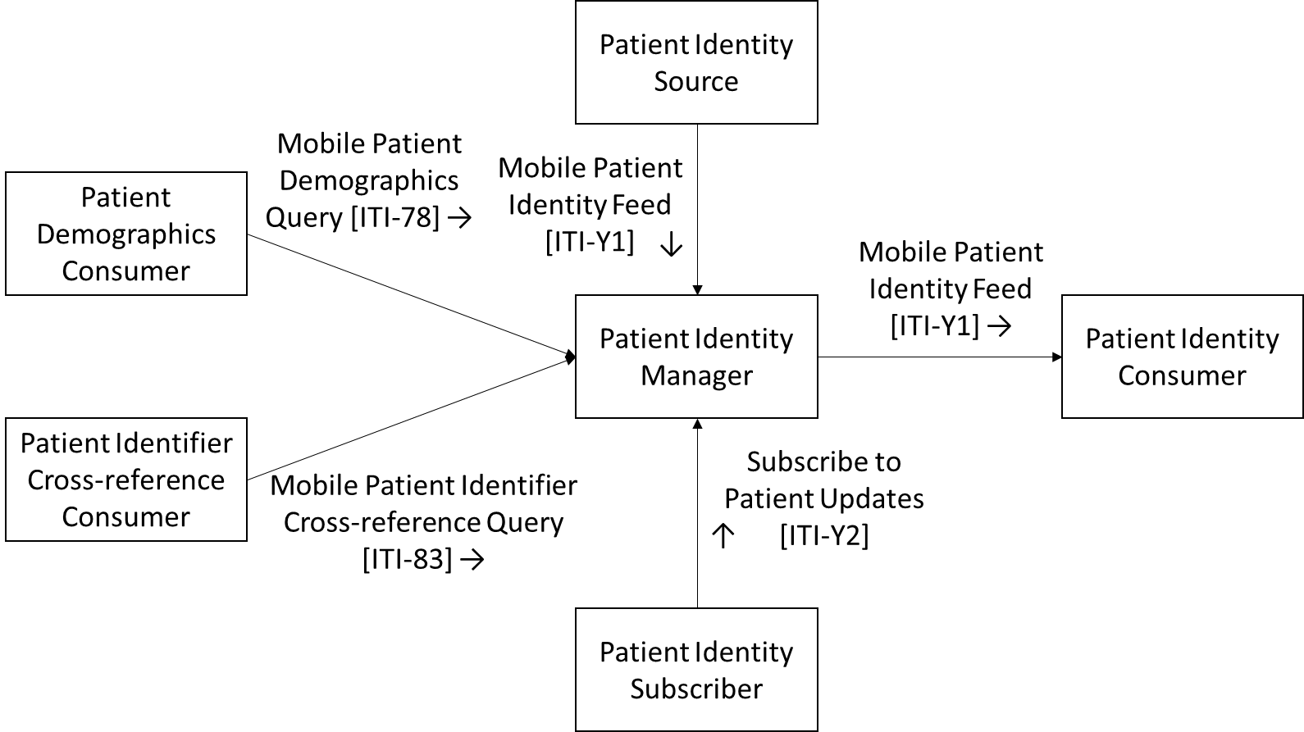

**Figure X.1-1: PRIM Actor Diagram**

Table X.1-1 lists the transactions for each actor directly involved in the PRIM Profile. To claim compliance with this profile, an actor shall support all required transactions (labeled “R”) and may support the optional transactions (labeled “O”).

**Table X.1-1: PRIM Profile - Actors and Transactions**

|  |  |  |  |
| --- | --- | --- | --- |
| Actors | Transactions | Optionality | Reference |
| Patient Identity Source | Mobile Patient Identity Feed [ITI-Y1] | R | ITI TF-2c: 3.Y1 |
| Patient Identity Consumer | Mobile Patient Identity Feed [ITI-Y1] | R | ITI TF-2c: 3.Y1 |
| Patient Identity Manager | Mobile Patient Identity Feed [ITI-Y1] | R | ITI TF-2c: 3.Y1 |
| Mobile Patient Identifier Cross-reference Query [ITI-83] | R | ITI TF-2c: 3.83  (Note 1) |
| Mobile Patient Demographics Query [ITI-78] | R | ITI TF-2c: 3.78  (Note 2) |
| Subscribe to Patient Updates [ITI-Y2] | R | ITI TF-2c: 3.Y2 |
| Patient Demographics Consumer | Mobile Patient Demographics Query [ITI-78] | R | ITI TF-2c: 3.83 |
| Patient Identifier Cross-reference Consumer | Mobile Patient Identifier Cross-reference Query [ITI-83] | R | ITI TF-2c: 3.83 |
| Patient Identity Subscriber | Subscribe to Patient Updates [ITI-Y2] | R | ITI TF-2c: 3.Y2 |

Note 1: The Patient Identity Manager shall respond to [ITI-83] queries using the requirements in that transaction for the Patient Identity Cross-Reference Manager.

Note 2: The Patient Identity Manager shall respond to [ITI-78] queries using the requirements in that transaction for the Patient Demographics Supplier.

## X.2 PRIM Actor Options

Options that may be selected for each actor in this profile, if any, are listed in the Table X.2-1. Dependencies between options, when applicable, are specified in notes.

**Table X.2-1: PRIM – Actors and Options**

|  |  |  |
| --- | --- | --- |
| Actor | Option Name | Reference |
| Patient Identity Source | None | -- |
| Patient Identity Consumer | None | -- |
| Patient Identity Manager | None | -- |
| Patient Identity Subscriber | None | -- |
| Patient Demographics Consumer | None | -- |
| Patient Identifier Cross-reference Consumer | None | -- |

## X.3 PRIM Required Actor Groupings

**Table X.3-1: PRIM Profile - Required Actor Groupings**

|  |  |  |  |
| --- | --- | --- | --- |
| PRIM Actor | Actor(s) to be grouped with | Reference | Content Bindings Reference |
| Patient Identity Source | -- | None | -- |
| Patient Identity Consumer | -- | None | *--* |
| Patient Identity Manager | -- | None | *--* |
| Patient Identity Subscriber | -- | None | *--* |
| Patient Demographics Consumer | -- | None | -- |
| Patient Identifier Cross-reference Consumer | -- | None | -- |

## X.4 PRIM Overview

### X.4.1 Concepts

Not applicable.

### X.4.2 Use Cases

#### X.4.2.1 Use Case #1: Create Patient

A new client record is created in a demographic database.

##### X.4.2.1.1 Create Patient Use Case Description

Following a healthy pregnancy, Mosa gives birth in a care facility to her new baby: Joshua. Information is captured about Joshua and about the relationship between him and his parents in the care facility’s electronic medical records (EMR) system. Leveraging the information in the EMR, a new demographic record is created for baby Joshua in the Ministry of Health’s (MOH) national Client Registry.

Joshua’s demographic record in the Client Registry establishes his unique identity across the care delivery network operated under the auspices of the MOH. Joshua’s data is also securely shared with the Civil Registration and Vital Statistics (CRVS) database maintained by the Ministry of Home Affairs in the country where Joshua was born. This CRVS data is used to generate a birth certificate for Joshua.

Some days after Mosa and Joshua return home from the care facility, Joshua’s health card and his birth certificate are delivered. Joshua now has his unique identifier for health purposes and his birth certificate, which affords him a legal status in his country.

##### X.4.2.1.2 Create Patient Process Flow

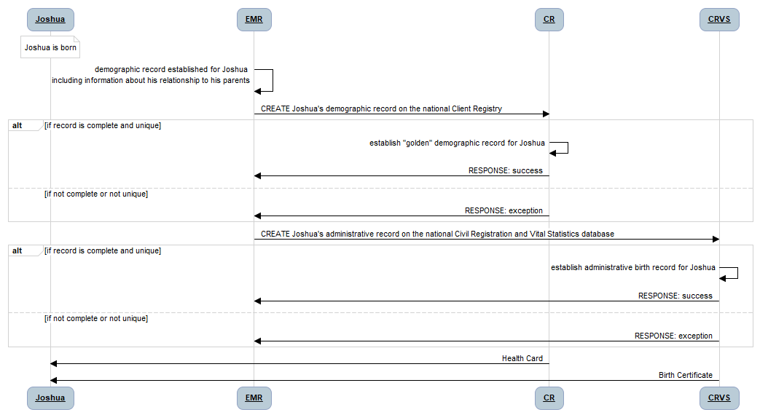

**Figure X.4.2.1.2-1: Process Flow for the Create Patient Use Case**

**Pre-conditions**:

Joshua is born at a care facility. The details about his name, his gender, and his parental relationships are known. These are captured in the care facility’s EMR.

**Main Flow**:

Joshua’s information in the care facility’s EMR is communicated to the MOH’s national Client Registry (CR). If the CREATE message is complete and if Joshua’s record does not create a duplicate on the CR, the EMR receives a “success” response -- otherwise an “exception” response is returned. Joshua’s information in the care facility’s EMR is also communicated to the MOHA’s national Civil Registration and Vital Statistics (CRVS) database. If the CREATE message is complete and if Joshua’s record does not create a duplicate on the CRVS, the EMR receives a “success” response -- otherwise an “exception” response is returned.

**Post-conditions:**

If the EMR message was complete and Joshua’s data did not create a duplicate record, his new “golden” demographic record will be established on the MOH’s CR and on the MOH’s CRVS. In time, Joshua will receive his health card and his birth certificate.

#### X.4.2.2 Use Case #2: Update Patient Information

An existing client record is updated in a demographic database.

##### X.4.2.2.1 Update Patient Use Case Description

Following a healthy childhood and after completing his schooling, Joshua leaves home to start a new job in a nearby city. As part of starting his new job at his new company, Joshua attends at a local community clinic in the new city to obtain a physical check-up as part of the process to become enrolled in the company’s health insurance plan.

Joshua’s demographic details are updated in the clinic’s EMR to reflect his new address and his new mobile phone number. The EMR updates the MOH CR with Joshua’s updated demographic details.

##### X.4.2.2.2 Update Patient Process Flow

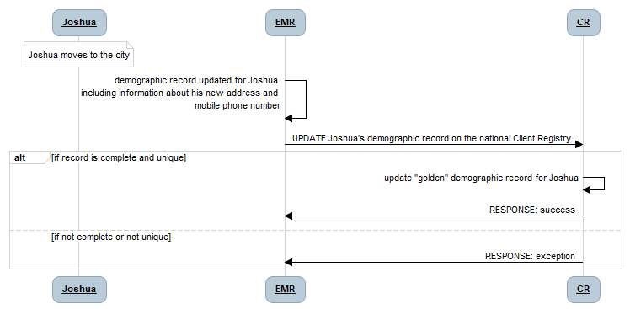

**Figure X.4.2.2.2-1: Process Flow for the Update Patient Use Case**

**Pre-conditions**:

Joshua has moved to the city and has a new address and mobile phone number. Joshua’s golden record is retrieved from the CR into the EMR and these updated details are captured in the community care facility’s EMR.

**Main Flow**:

Joshua’s information in the care facility’s EMR is communicated as an UPDATE to the MOH’s national Client Registry (CR). If the data message is complete and if Joshua’s record does not create a duplicate on the CR, the EMR receives a “success” response -- otherwise an “exception” response is returned.

**Post-conditions:**

If the EMR message was complete, his existing “golden” demographic record will be updated on the MOH’s CR with the new, more up-to-date information that was captured in the community clinic’s EMR.

#### X.4.2.3 Use Case #3: Link Patient Records

A duplicate client record has been created, in error, in a demographic database. This duplicate record is Linked with the pre-existing *correct* demographic record and health data that has been captured, in error, against the duplicate client ID is linked to the correct, *surviving*, client ID. This Linking is often referred to as Merge, however technically the result is Linking.

##### X.4.2.3.1 Link Patient Records Use Case Description

Joshua becomes concerned and travels to a different city to visit a Voluntary Counseling and Testing (VCT) clinic to be tested for HIV. He pretends that he has forgotten his health card and provides inaccurate demographic information at the VCT, who set up a new record for him in their EMR. The EMR communicates this demographic information to the MOH’s CR where, in error, a new demographic record for Joshua is established.

Joshua completes the HIV rapid test, which is positive. A confirmatory test is taken, which has to be sent to the regional lab for processing. Both the results of the rapid test and the results of the confirmatory test reference Joshua’s **duplicate** demographic record.

When Joshua returns to the clinic to receive his confirmatory lab results, and after receiving counselling regarding confidentiality rules and the importance of care continuity, Joshua corrects his demographic information. The EMR merges Joshua’s two demographic records to a single unique ID# and sends a Link message to the national CR to do the same.

The various databases that store health information about Joshua have subscribed to update transactions on the national CR. To ensure patient safety for Joshua, these systems ensure that a query using Joshua’s resolved unique ID# would, correctly, return all of the health information associated with him -- whether it was originally persisted under his duplicate ID# or under his post-merge unique ID#.

##### X.4.2.3.2 Merge Patient Process Flow

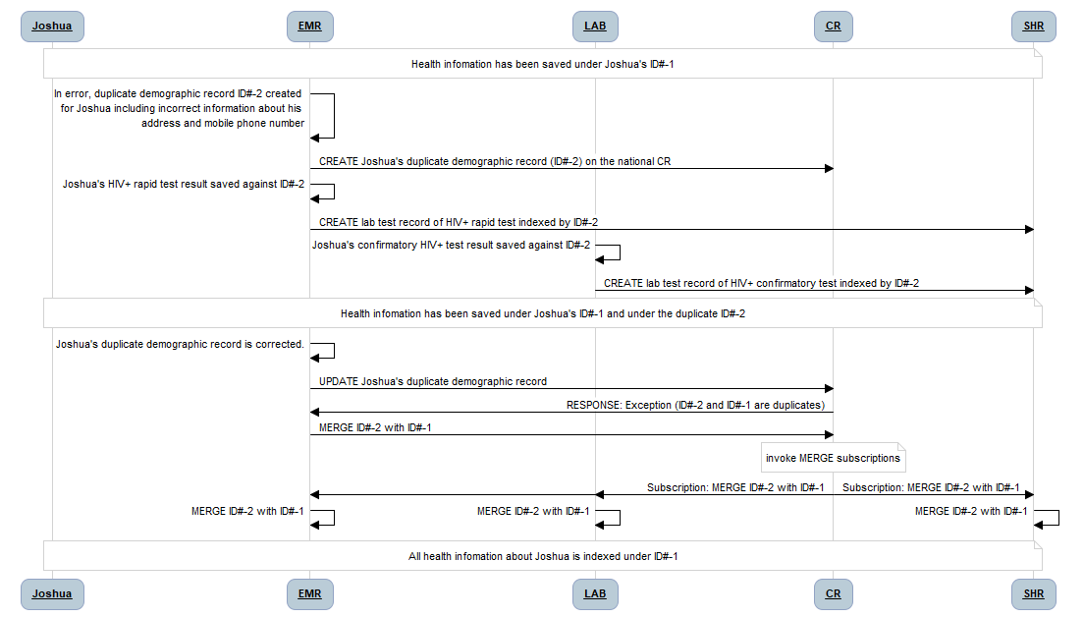

**Figure X.4.2.3.2-1: Process Flow for the Link Patient Use Case**

**Pre-conditions**:

Systems that maintain patient information subscribe to the needed Patient data on the national Client Registry.

**Main Flow**:

A duplicate demographic record is, in error, created on the national CR. When the error is found, a transaction is executed to Link two demographic records on the CR. This triggers the subscriptions, and health data systems that have subscribed to updates on the CR are updated with information about the ID#s that are to be merged. Each of these systems updates their local health data to reflect the Link message.

**Post-conditions:**

Following the execution of the triggered Link message, each system that maintains health data about the subject of care has updated this local data to reflect the Link of the two demographic ID#s. The subsumed identifier is deprecated,

## X.5 PRIM Security Considerations

See Appendix Z.8 for general FHIR security considerations.

In addition, the PRIM profile is communicating Patient Identity information including identifiers, addresses, demographics, and contact information. This information is personal identifiers, and the identity is linked to health information. Care must be taken to protect the Privacy of the Patient and the Security of system.

## X.6 PRIM Cross Profile Considerations

Any system that implements the Patient Identity Consumer must follow the link and unlink actions. Link and unlink apply to all actors that system implements.

**Appendices**

Not applicable.

Volume 2c – Transactions

Add Section 3.Y1

## 3.Y1 Mobile Patient Identity Feed [ITI-Y1]

### 3.Y1.1 Scope

The Mobile Patient Identity Feed transaction sends a bundle of new and updated Patient resources.

### 3.Y1.2 Actor Roles

The roles in this transaction are defined in the following table and may be played by the actors shown here:

Table 3.Y1.2-1 Actor Roles

|  |  |
| --- | --- |
| **Role:** | Supplier: Sends a bundle of updates. |
| **Actor(s):** | The following actors may play the role of *Supplier:*  Patient Identity Source  Patient Identity Manager |
| **Role:** | Consumer: Accepts the bundle request and returns a bundle response. |
| **Actor(s):** | The following actors may play the role of *Consumer:*  Patient Identity Manager  Patient Identity Consumer |

### 3.Y1.3 Referenced Standards

* HL7 FHIR standard Release 4 http://hl7.org/fhir/R4/index.html
* JSON – IETF RFC7159
* XML
* HTTP 1.1

### 3.Y1.4 Interaction Diagram

Mobile Patient Identity Feed Response

Mobile Patient Identity Feed Request

Supplier

Consumer

#### 3.Y1.4.1 Mobile Patient Identity Feed Request Message

The Mobile Patient Identity Feed message is a FHIR message with the new and updated Patient Resource(s).

##### 3.Y1.4.1.1 Trigger Events

A Supplier triggers a Mobile Patient Identity Feed Request to a Consumer when patients are created, updates, or deletions are made to the underlying patient data, such as link, unlink, identifier, or demographic changes.

##### 3.Y1.4.1.2 Message Semantics

A Supplier initiates a FHIR message request using HTTP POST as defined at <https://www.hl7.org/fhir/R4/messaging.html> on a Bundle Resource.

A Consumer shall support accepting a request for both the JSON and the XML messaging formats as defined in FHIR. A Supplier shall send either the JSON or the XML messaging formats as defined in FHIR. See ITI TF-2x: Appendix Z.6 for more details.

##### 3.Y1.4.1.2.1 FHIR Bundle Resource Constraints

The Bundle Resource shall be further constrained as described in Table 3.Y1.4.1.2.1-1. The Element column in Table 3.Y1.4.1.2.1-1 references the object model defined at <https://www.hl7.org/fhir/R4/bundle.html#resource>.

Table 3.Y1.4.1.2.1-1: Bundle Resource Constraints

| Element  &  Cardinality | Constraints |
| --- | --- |
| type [1..1] | Shall be: Message |
| entry [2..*] | The first resource in the entry list shall be a MessageHeader Resource.  The remaining entries shall be Patient Resource(s). |
| entry.request.method | This should indicate created, updated, or deleted records.  POST | PUT | DELETE |

##### 3.Y1.4.1.2.2 FHIR MessageHeader Resource Constraints

A Supplier shall create a Bundle Resource of type “message” with the first entry being a MessageHeader Resource. The MessageHeader Resource shall be further constrained as described in Table 3.Y1.4.1.2.2-1. The Element column in Table 3.Y1.4.1.2.2-1 references the object model defined at <https://www.hl7.org/fhir/R4/messageheader.html#resource>.

Table 3.Y1.4.1.2.2-1: MessageHeader Resource Constraints

| Element  &  Cardinality | Constraints |
| --- | --- |
| eventUri [1..1] | Shall be one of:  urn:ihe:iti:prim:2019:patient-link  urn:ihe:iti:prim:2019:patient-unlink  urn:ihe:iti:prim:2019:patient-update |
| focus [1..*] | Reference(Patient)  The list of patients being sent in this feed. |
| destination [1..*] | The destination(s) of this feed. |
| sender [0..1] | Required if known. |
| enterer [0..1] | Required if known. |
| author [0..1] | Required if known. |
| responsible [0..1] | Required if known. |

The eventUri shall be patient-link when the update is a link between 2 or more Patients. The eventUri shall be patient-unlink when the update removes a link between 2 or more Patients.

When the eventUri is patient-link, the Bundle Resource shall include at least 2 Patient Resources that are being linked with the link element populated. A Consumer shall treat linked patient resources as if they were the same resource. E.g. when queries are handled on resources that reference one of the linked patients, resources that reference all linked patients will be returned.

When the eventUri is patient-unlink, the Bundle Resource shall include at least 2 Patient Resources that are being unlinked with the link element removed.

When the eventUri is patient-update, the Bundle Resource shall include at least 1 Patient Resource that has been updated.

See ITI TF-2x: Appendix W for informative implementation material for this transaction.

##### 3.Y1.4.1.3 Expected Actions

A Consumer shall accept the message, return a Mobile Patient Identity Feed Response message (Section 3.Y1.4.2).

A Consumer who is a Patient Identity Manager shall:

* treat linked patients as if they were the same when the message includes a link of two or more Patient Resources.
* not treat patients as if they were the same when the message includes an unlink of two or more Patient Resources
* persist updates when other updates to Patient Resources are made.

#### 3.Y1.4.2 Mobile Patient Identity Feed Response

##### 3.Y1.4.2.1 Trigger Events

A Consumer sends the Mobile Patient Identity Feed Response to the Supplier when the message is accepted.

##### 3.Y1.4.2.2 Message Semantics

A Consumer responds to the Mobile Patient Identity Feed Request with an HTTP Status of 2xx or an error code, 4xx or 5xx.

##### 3.Y1.4.2.3 Expected Actions

The Supplier has received the response and continues with its workflow.

### 3.Y1.5 Security Considerations

See ITI TF-1: X.5 for security considerations for the PRIM Profile.

See ITI TF-2x: Appendix Z.8 for common mobile security considerations.

#### 3.Y2.5.1 Security Audit Considerations

The Mobile Patient Identity Feed transaction is a Patient Record Message event as defined in ITI TF-2a: 3.20.4.1.1.1-1.

Note that the same auditEvent is recorded by both Supplier and Consumer. The difference being the Audit Source element. Both sides record to show consistency between message sent by the Supplier and action taken at the Consumer.

The actors involved shall record audit events according to the following:

##### 3.Y2.5.1.1 Supplier audit message:

|  |  |  |  |
| --- | --- | --- | --- |
|  | Field Name | Opt | Value Constraints |
| Event  AuditMessage/ EventIdentification | EventID | M | EV(110110, DICOM, “Patient Record”) |
| EventActionCode | M | EV(batch, http://hl7.org/fhir/restful-interaction, “batch” |
| *EventDateTime* | *M* | *not specialized* |
| *EventOutcomeIndicator* | *M* | *not specialized* |
| EventTypeCode | M | EV(“ITI-Y1”, “IHE Transactions”, “Mobile Patient Identity Feed”) |
| Source (Supplier) (1) | | | |
| Destination (Consumer) (1) | | | |
| Audit Source (Supplier) (1) | | | |
| Patient (1..N) Patient Identities in the message | | | |
| Message Identity (1) | | | |

Where:

|  |  |  |  |
| --- | --- | --- | --- |
| Source  AuditMessage/ ActiveParticipant | UserID | M | OAuth App client_id |
| AlternativeUserID | *U* | *not specialized* |
| *UserName* | *U* | *not specialized* |
| *UserIsRequestor* | *U* | *not specialized* |
| RoleIDCode | M | EV(110153, DCM, “Source”) |
| NetworkAccessPointTypeCode | M | “1” for machine (DNS) name, “2” for IP address |
| NetworkAccessPointID | M | The machine name or IP address. |

|  |  |  |  |
| --- | --- | --- | --- |
| Destination  AuditMessage/ ActiveParticipant | UserID | M | http endpoint URI. |
| *AlternativeUserID* | *U* | *not specialized* |
| *UserName* | *U* | *not specialized* |
| UserIsRequestor | M | “false” |
| RoleIDCode | M | EV(110152, DCM, “Destination”) |
| NetworkAccessPointTypeCode | M | “1” for machine (DNS) name, “2” for IP address |
| NetworkAccessPointID | M | The machine name or IP address. |

|  |  |  |  |
| --- | --- | --- | --- |
| Audit Source  AuditMessage/ AuditSourceIdentification | *AuditSourceID* | *U* | *not specialized* |
| *AuditEnterpriseSiteID* | *U* | *not specialized* |
| *AuditSourceTypeCode* | *U* | *not specialized* |

|  |  |  |  |
| --- | --- | --- | --- |
| Patient  (AuditMessage/ ParticipantObjectIdentification)  (1..N) | ParticipantObjectTypeCode | M | “1” (Person) |
| ParticipantObjectTypeCodeRole | M | “1” (Patient) |
| *ParticipantObjectDataLifeCycle* | *U* | *not specialized* |
| *ParticipantObjectIDTypeCode* | *M* | *not specialized* |
| *ParticipantObjectSensitivity* | *U* | *not specialized* |
| ParticipantObjectID | M | The Patient._id value |
| *ParticipantObjectName* | *U* | *not specialized* |
| *ParticipantObjectQuery* | *U* | *not specialized* |
| *ParticipantObjectDetail* | *U* | *not specialized* |

|  |  |  |  |
| --- | --- | --- | --- |
| Message Identity  (AuditMessage/ ParticipantObjectIdentification) | ParticipantObjectTypeCode | M | EV(MessageHeader, http://hl7.org/fhir/resource-types, “MessageHeader) |
| ParticipantObjectTypeCodeRole | *U* | *not specialized* |
| *ParticipantObjectDataLifeCycle* | *U* | *not specialized* |
| ParticipantObjectIDTypeCode | *U* | *not specialized* |
| *ParticipantObjectSensitivity* | *U* | *not specialized* |
| *ParticipantObjectID* | *M* | *MessageHeader._id value* |
| *ParticipantObjectName* | *M* | *MessageHeader.eventUri value* |
| ParticipantObjectQuery | *U* | *not specialized* |
| ParticipantObjectDetail | *U* | *not specialized* |

##### 3.Y2.5.1.2 Patient Identity Manager audit message:

|  |  |  |  |
| --- | --- | --- | --- |
|  | Field Name | Opt | Value Constraints |
| Event  AuditMessage/ EventIdentification | EventID | M | EV(110110, DICOM, “Patient Record”) |
| EventActionCode | M | EV(batch, http://hl7.org/fhir/restful-interaction, “batch” |
| *EventDateTime* | *M* | *not specialized* |
| *EventOutcomeIndicator* | *M* | *not specialized* |
| EventTypeCode | M | EV(“ITI-Y1”, “IHE Transactions”, “Mobile Patient Identity Feed”) |
| Source (Supplier) (1) | | | |
| Destination (Consumer) (1) | | | |
| Audit Source (Consumer) (1) | | | |
| Patient (1..N) Patient Identities in the message | | | |
| Message Identity (1) | | | |

Where:

|  |  |  |  |
| --- | --- | --- | --- |
| Source  AuditMessage/ ActiveParticipant | UserID | M | OAuth App client_id |
| AlternativeUserID | *U* | *not specialized* |
| *UserName* | *U* | *not specialized* |
| *UserIsRequestor* | *U* | *not specialized* |
| RoleIDCode | M | EV(110153, DCM, “Source”) |
| NetworkAccessPointTypeCode | M | “1” for machine (DNS) name, “2” for IP address |
| NetworkAccessPointID | M | The machine name or IP address. |

|  |  |  |  |
| --- | --- | --- | --- |
| Destination  AuditMessage/ ActiveParticipant | UserID | M | http endpoint URI. |
| *AlternativeUserID* | *U* | *not specialized* |
| *UserName* | *U* | *not specialized* |
| UserIsRequestor | M | “false” |
| RoleIDCode | M | EV(110152, DCM, “Destination”) |
| NetworkAccessPointTypeCode | M | “1” for machine (DNS) name, “2” for IP address |
| NetworkAccessPointID | M | The machine name or IP address. |

|  |  |  |  |
| --- | --- | --- | --- |
| Audit Source  AuditMessage/ AuditSourceIdentification | *AuditSourceID* | *U* | *not specialized* |
| *AuditEnterpriseSiteID* | *U* | *not specialized* |
| *AuditSourceTypeCode* | *U* | *not specialized* |

|  |  |  |  |
| --- | --- | --- | --- |
| Patient  (AuditMessage/ ParticipantObjectIdentification)  (1..N) | ParticipantObjectTypeCode | M | “1” (Person) |
| ParticipantObjectTypeCodeRole | M | “1” (Patient) |
| *ParticipantObjectDataLifeCycle* | *U* | *not specialized* |
| *ParticipantObjectIDTypeCode* | *M* | *not specialized* |
| *ParticipantObjectSensitivity* | *U* | *not specialized* |
| ParticipantObjectID | M | The Patient._id value |
| *ParticipantObjectName* | *U* | *not specialized* |
| *ParticipantObjectQuery* | *U* | *not specialized* |
| *ParticipantObjectDetail* | *U* | *not specialized* |

|  |  |  |  |
| --- | --- | --- | --- |
| Message Identity  (AuditMessage/ ParticipantObjectIdentification) | ParticipantObjectTypeCode | M | EV(MessageHeader, http://hl7.org/fhir/resource-types, “MessageHeader) |
| ParticipantObjectTypeCodeRole | *U* | *not specialized* |
| *ParticipantObjectDataLifeCycle* | *U* | *not specialized* |
| ParticipantObjectIDTypeCode | *U* | *not specialized* |
| *ParticipantObjectSensitivity* | *U* | *not specialized* |
| *ParticipantObjectID* | *M* | *MessageHeader._id value* |
| *ParticipantObjectName* | *M* | *MessageHeader.eventUri value* |
| ParticipantObjectQuery | *U* | *not specialized* |
| ParticipantObjectDetail | *U* | *not specialized* |

Add Section 3.Y2

## 3.Y2 Subscribe to Patient Updates [ITI-Y2]

### 3.Y2.1 Scope

The Subscribe to Patient Updates transaction allows a Patient Identity Subscriber to subscribe to a Mobile Patient Resource Feed depending on the requested criteria.

### 3.Y2.2 Actor Roles

Table 3.Y2.2-1: Actor Roles

|  |  |
| --- | --- |
| **Actor:** | Patient Identity Subscriber |
| **Role:** | Sends a Subscription request to the Patient Identity Manager |
| **Actor:** | Patient Identity Manager |
| **Role:** | Accepts a Subscription request and returns where the Subscription can be accessed. |

### 3.Y2.3 Referenced Standards

* HL7 FHIR standard Release 4 http://hl7.org/fhir/R4/index.html
* JSON – IETF RFC7159
* XML
* HTTP 1.1

### 3.Y2.4 Interaction Diagram

Subscribe to Patient Updates Response

Subscribe to Patient Updates Request

Patient Identity Subscriber

Patient Identity Manager

Get Patient Subscription Response

Get Patient Subscription Request

Enable/Disable Patient Subscription Response

Enable/Disable Patient Subscription Request

Delete Patient Subscription Response

Delete Patient Subscription Request

#### 3.Y2.4.1 Subscribe to Patient Updates Request Message

The Subscribe to Patient Updates message is a FHIR create operation on a Subscription Resource.

##### 3.Y2.4.1.1 Trigger Events

A Patient Identity Subscriber triggers a Subscribe to Patient Updates Request to a Patient Identity Manager according to the business rules for the subscription. These business rules are outside the scope of this transaction.

##### 3.Y2.4.1.2 Message Semantics

A Patient Subscriber initiates a FHIR create request using HTTP POST as defined at <https://www.hl7.org/fhir/R4/http.html#create> on the Subscription Resource as defined at <https://www.hl7.org/fhir/R4/subscription.html>.

A Patient Identity Manager shall support accepting a request for both the JSON and the XML messaging formats as defined in FHIR. A Patient Subscriber shall send either the JSON or the XML messaging formats as defined in FHIR. See ITI TF-2x: Appendix Z.6 for more details.

See ITI TF-2x: Appendix W for informative implementation material for this transaction.

##### 3.Y2.4.1.2.1 FHIR Subscription Resource Constraints

A Patient Identity Subscriber shall create a Subscription Resource. The Subscription Resource shall be further constrained as described in Table 3.Y2.4.1.2.1-1. The Element column in Table 3.Y2.4.1.2.1-1 references the object model defined at <https://www.hl7.org/fhir/R4/subscription.html#resource>.

Table 3.Y2.4.1.2.1-1: Subscription Resource Constraints

| Element  &  Cardinality | Constraints |
| --- | --- |
| channel.type [1..1] | The type shall be “message.” |
| channel.endpoint [1..1] | The endpoint must be a defined URL. |
| channel.payload [1..1] | The payload shall be either:  application/fhir+json  application/fhir+xml |
| status [1..1] | The status shall be “requested.” |
| contact [0..*] | The contact for the subscription. |
| contact.system [1..1] | The system of the contact value. |
| contact.value [1..1] | The value where the contact can be reached. |
| criteria | The Patient Identity Manager shall support any of the following:  Patient  Patient?_id=X |

##### 3.Y2.4.1.3 Expected Actions

A Patient Identity Manager shall accept the request, and return an HTTP 201 response when the Subscription is created or an error code with an OperationOutcome if an error occurs as per <https://www.hl7.org/fhir/http.html#create>. A Patient Identity Manager will create a job to manage the subscription which is beyond the scope of this document. When the job has been activated , the Subscription Resource status shall be changed to “active.”

The Patient Identity Manager shall use the Mobile Patient Identity Feed [ITI-Y1] to send updates to the Patient Identity Consumer defined in the Subscription channel endpoint based on the trigger criteria defined in the Subscription Resource if the status is set to “active.”

If an error occurs at any time with the active subscription, the Patient Identity Manager shall update the Subscription Resource and set the error element with the error message. The Patient Identity Subscriber may use the Get Patient Subscription Request to get the current status of the Subscription.

#### 3.Y2.4.2 Subscribe to Patient Updates Response

##### 3.Y2.4.2.1 Trigger Events

A Patient Identity Manager sends the Subscribe to Patient Updates Response to the Patient Subscriber when the subscription request is accepted.

##### 3.Y2.4.2.2 Message Semantics

A Patient Identity Manager responds to the Subscribe to Patient Updates Request with an HTTP Status of 201 with the Location header set to the created Subscription Resource or an error as defined at <https://www.hl7.org/fhir/http.html#create>.

##### 3.Y2.4.2.3 Expected Actions

A Patient Identity Subscriber has received the response and continues with its workflow. It should maintain the returned Subscription ID so it can be queried for status, disabled, or deleted later.

#### 3.Y2.4.3 Get Patient Subscription Request/Response Message

A Patient Identity Subscriber can retrieve the current details of a subscription by accessing the location returned by the Subscribe to Patient Updates Response as defined at <https://www.hl7.org/fhir/http.html#read>.

#### 3.Y2.4.4 Enable/Disable Patient Subscription Request/Response Message

A Patient Subscriber can enable or disable the given subscription by accessing the location returned by the Subscribe to Patient Updates Response as defined at <https://www.hl7.org/fhir/http.html#update>. This can be used to temporarily disable the subscription by changing the status to “off” or re-enable a subscription by changing the status to “requested.” A Patient Identity Manager will suspend a subscription when the status is “off.” Any new changes with a status of “requested” will be handled as per 3.Y2.4.1.3.

#### 3.Y2.4.5 Delete Patient Subscription Request/Response Message

A Patient Subscriber can delete a subscription by accessing the location returned by the Subscribe to Patient Updates Response as defined at <https://www.hl7.org/fhir/http.html#delete>. A Patient Identity Manager shall stop sending the Mobile Patient Identity Feed to the subscribed destination.

### 3.Y2.5 Security Considerations

See ITI TF-1: X.5 for security considerations for the PRIM Profile.

See ITI TF-2x: Appendix Z.8 for common mobile security considerations.

#### 3.Y2.5.1 Security Audit Considerations

The Subscribe to Patient Updates transaction is a REST Information event as defined in ITI TF-2a: 3.20.4.1.1.1-1.

Note that the same auditEvent is recorded by both Patient Subscriber and Patient Identity Manager. The difference being the Audit Source element. Both sides record so as to show consistency between request given by the Patient Subscriber and action taken at the Patient Identity Manager.

The actors involved shall record audit events according to the following:

##### 3.Y2.5.1.1 Patient Subscriber audit message:

|  |  |  |  |
| --- | --- | --- | --- |
|  | Field Name | Opt | Value Constraints |
| Event  AuditMessage/ EventIdentification | EventID | M | EV(“rest”, http://terminology.hl7.org/CodeSystem/audit-event-type, “rest”) |
| EventActionCode | M | code one of (create, read, update, delete) system http://hl7.org/fhir/restful-interactions |
| *EventDateTime* | *M* | *not specialized* |
| *EventOutcomeIndicator* | *M* | *not specialized* |
| EventTypeCode | M | EV(“ITI-Y2”, “IHE Transactions”, “Subscribe to Patient Updates”) |
| Source (Patient Subscriber) (1) | | | |
| Human Requestor (0..n) | | | |
| Destination (Patient Identity Manager) (1) | | | |
| Audit Source (Patient Subscriber) (1) | | | |
| Patient (0..1) Patient if specific. | | | |
| Query Parameters (1) | | | |

Where:

|  |  |  |  |
| --- | --- | --- | --- |
| Source  AuditMessage/ ActiveParticipant | UserID | M | OAuth App client_id |
| AlternativeUserID | *U* | *not specialized* |
| *UserName* | *U* | *not specialized* |
| *UserIsRequestor* | *U* | *not specialized* |
| RoleIDCode | M | EV(110153, DCM, “Source”) |
| NetworkAccessPointTypeCode | M | “1” for machine (DNS) name, “2” for IP address |
| NetworkAccessPointID | M | The machine name or IP address. |

|  |  |  |  |
| --- | --- | --- | --- |
| Human Requestor (if known)  AuditMessage/ ActiveParticipant | UserID | M | Identity of the human that initiated the transaction. |
| *AlternativeUserID* | *U* | *not specialized* |
| *UserName* | *U* | *not specialized* |
| *UserIsRequestor* | *U* | *not specialized* |
| RoleIDCode | U | Access Control role(s) the user holds that allows this transaction. |
| *NetworkAccessPointTypeCode* | *U* | *not specialized* |
| *NetworkAccessPointID* | *U* | *not specialized* |

|  |  |  |  |
| --- | --- | --- | --- |
| Destination  AuditMessage/ ActiveParticipant | UserID | M | http endpoint URI. |
| *AlternativeUserID* | *U* | *not specialized* |
| *UserName* | *U* | *not specialized* |
| UserIsRequestor | M | “false” |
| RoleIDCode | M | EV(110152, DCM, “Destination”) |
| NetworkAccessPointTypeCode | M | “1” for machine (DNS) name, “2” for IP address |
| NetworkAccessPointID | M | The machine name or IP address. |

|  |  |  |  |
| --- | --- | --- | --- |
| Audit Source  AuditMessage/ AuditSourceIdentification | *AuditSourceID* | *U* | *not specialized* |
| *AuditEnterpriseSiteID* | *U* | *not specialized* |
| *AuditSourceTypeCode* | *U* | *not specialized* |

|  |  |  |  |
| --- | --- | --- | --- |
| Patient  (AuditMessage/ ParticipantObjectIdentification) | ParticipantObjectTypeCode | M | “1” (Person) |
| ParticipantObjectTypeCodeRole | M | “1” (Patient) |
| *ParticipantObjectDataLifeCycle* | *U* | *not specialized* |
| *ParticipantObjectIDTypeCode* | *M* | *not specialized* |
| *ParticipantObjectSensitivity* | *U* | *not specialized* |
| ParticipantObjectID | M | The Patient._id value |
| *ParticipantObjectName* | *U* | *not specialized* |
| *ParticipantObjectQuery* | *U* | *not specialized* |
| *ParticipantObjectDetail* | *U* | *not specialized* |

|  |  |  |  |
| --- | --- | --- | --- |
| Query Parameters  (AuditMessage/ ParticipantObjectIdentification) | ParticipantObjectTypeCode | M | “2” (system object) |
| ParticipantObjectTypeCodeRole | M | “24” (query) |
| *ParticipantObjectDataLifeCycle* | *U* | *not specialized* |
| ParticipantObjectIDTypeCode | M | EV(“ITI-Y2, “IHE Transactions”, “Subscribe to Patient Update”) |
| *ParticipantObjectSensitivity* | *U* | *not specialized* |
| *ParticipantObjectID* | *C* | *Subscription._id value – when known (empty on create)* |
| *ParticipantObjectName* | *U* | *not specialized* |
| ParticipantObjectQuery | M | the Subscription.criteria value |
| ParticipantObjectDetail | *U* | *not specialized* |

##### 3.Y2.5.1.2 Patient Identity Manager audit message:

|  |  |  |  |
| --- | --- | --- | --- |
|  | Field Name | Opt | Value Constraints |
| Event  AuditMessage/ EventIdentification | EventID | M | EV(“rest”, http://terminology.hl7.org/CodeSystem/audit-event-type, “rest”) |
| EventActionCode | M | code one of (create, read, update, delete) system http://hl7.org/fhir/restful-interactions |
| *EventDateTime* | *M* | *not specialized* |
| *EventOutcomeIndicator* | *M* | *not specialized* |
| EventTypeCode | M | EV(“ITI-Y2”, “IHE Transactions”, “Subscribe to Patient Updates”) |
| Source (Patient Subscriber) (1) | | | |
| Human Requestor (0..n) | | | |
| Destination (Patient Identity Manager) (1) | | | |
| Audit Source (Patient Identity Manager) (1) | | | |
| Patient (0..1) Patient if specific. | | | |
| Query Parameters (1) | | | |

Where:

|  |  |  |  |
| --- | --- | --- | --- |
| Source  AuditMessage/ ActiveParticipant | UserID | M | oAuth App client_id |
| AlternativeUserID | *U* | *not specialized* |
| *UserName* | *U* | *not specialized* |
| *UserIsRequestor* | *U* | *not specialized* |
| RoleIDCode | M | EV(110153, DCM, “Source”) |
| NetworkAccessPointTypeCode | M | “1” for machine (DNS) name, “2” for IP address |
| NetworkAccessPointID | M | The machine name or IP address. |

|  |  |  |  |
| --- | --- | --- | --- |
| Human Requestor (if known)  AuditMessage/ ActiveParticipant | UserID | M | Identity of the human that initiated the transaction. |
| *AlternativeUserID* | *U* | *not specialized* |
| *UserName* | *U* | *not specialized* |
| *UserIsRequestor* | *U* | *not specialized* |
| RoleIDCode | U | Access Control role(s) the user holds that allows this transaction. |
| *NetworkAccessPointTypeCode* | *U* | *not specialized* |
| *NetworkAccessPointID* | *U* | *not specialized* |

|  |  |  |  |
| --- | --- | --- | --- |
| Destination  AuditMessage/ ActiveParticipant | UserID | M | http endpoint URI. |
| *AlternativeUserID* | *U* | *not specialized* |
| *UserName* | *U* | *not specialized* |
| UserIsRequestor | M | “false” |
| RoleIDCode | M | EV(110152, DCM, “Destination”) |
| NetworkAccessPointTypeCode | M | “1” for machine (DNS) name, “2” for IP address |
| NetworkAccessPointID | M | The machine name or IP address. |

|  |  |  |  |
| --- | --- | --- | --- |
| Audit Source  AuditMessage/ AuditSourceIdentification | *AuditSourceID* | *U* | *not specialized* |
| *AuditEnterpriseSiteID* | *U* | *not specialized* |
| *AuditSourceTypeCode* | *U* | *not specialized* |

|  |  |  |  |
| --- | --- | --- | --- |
| Patient  (AuditMessage/ ParticipantObjectIdentification) | ParticipantObjectTypeCode | M | “1” (Person) |
| ParticipantObjectTypeCodeRole | M | “1” (Patient) |
| *ParticipantObjectDataLifeCycle* | *U* | *not specialized* |
| *ParticipantObjectIDTypeCode* | *M* | *not specialized* |
| *ParticipantObjectSensitivity* | *U* | *not specialized* |
| ParticipantObjectID | M | The Patient._id value |
| *ParticipantObjectName* | *U* | *not specialized* |
| *ParticipantObjectQuery* | *U* | *not specialized* |
| *ParticipantObjectDetail* | *U* | *not specialized* |

|  |  |  |  |
| --- | --- | --- | --- |
| Query Parameters  (AuditMessage/ ParticipantObjectIdentification) | ParticipantObjectTypeCode | M | “2” (system object) |
| ParticipantObjectTypeCodeRole | M | “24” (query) |
| *ParticipantObjectDataLifeCycle* | *U* | *not specialized* |
| ParticipantObjectIDTypeCode | M | EV(“ITI-Y2, “IHE Transactions”, “Subscribe to Patient Update”) |
| *ParticipantObjectSensitivity* | *U* | *not specialized* |
| *ParticipantObjectID* | *C* | *Subscription._id value* |
| *ParticipantObjectName* | *U* | *not specialized* |
| ParticipantObjectQuery | M | the Subscription.criteria value |
| ParticipantObjectDetail | *U* | *not specialized* |

Replace Section 3.78.2

### 3.78.2 Actor Roles

Patient Identity Manager

Patient Demographics Consumer

Patient Demographics Supplier

Figure 3.78.2-1: Use Case Diagram

Table 3.78.2-1: Actor Roles

|  |  |
| --- | --- |
| **Role:** | Patient Demographics Consumer: Requests a list of patients matching the supplied set of demographics criteria (example: ID or Name) from the Patient Demographics Supplier. The Patient Demographics Consumer populates its attributes with demographic information received from the Patient Demographics Supplier. |
| **Actor(s):** | The following actors may play the role of Patient Demographics Consumer:  Patient Demographics Consumer |
| **Role:** | Patient Demographics Supplier: Returns demographic information for all patients matching the demographics criteria provided by the Patient Demographics Consumer. |
| **Actor(s):** | The following actors may play the role of Patient Demographics Supplier:  Patient Demographics Supplier  Patient Identity Manager |

1. HL7 is the registered trademark of Health Level Seven International.
2. FHIR is the registered trademark of Health Level Seven International.